2APHY: Nuclear Physics Mid unit Test ANSWERS
Name: __________________________________________________ (33 marks + overall = 34 marks)
OVERALL: Additional 1 mark for units and significant figures.
- Complete the table below: (2 marks) - ½ mark for each wrong answer 2 marks

Element | Nuclide | Atomic Number | Number of Neutrons | Mass Number
Nitrogen - 14 | 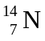 | 7 | 7 | 14
Helium-4 | 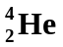 | 2 | 2 | 4
Carbon-14 | 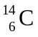 | 6 | 8 | 14

- Fully explain what an isotope is using examples. (3 marks)
Isotopes are different forms of the same element. 1 mark

They have the same mass number (number of protons) but different mass number (number of neutrons). 1 mark

Example is carbon-12 and carbon-14 which both have 6 protons but carbon-12 has 6 neutrons and carbon-14 has 8 neutrons. 1 mark

- For each of the following, name the radiation emitted, its symbol and what the radiation is and what will stop it. [Level 4] (3 marks) 1 mark for each correct row

Nuclear Equation | Nuclide | Radiation name | Symbol | What is the radiation made of?
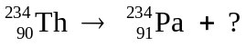 | 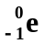 | beta | β | High speed electron from within nucleus
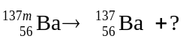 | 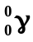 | gamma | γ | Electromagnetic radation
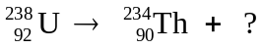 |  | alpha | α | Two protons and two neutrons from with nucleus – like a helium atom

- A radiographer wants to investigate blood circulation in a patient. There are a number of radioisotopes available. What properties would you look for to select one? Give three reasons.
(3 marks)

- Short half life
- High activity
- Beta emitter is most commonly used
- Radioisotope common to the body
- Etc
Any three that are reasonable properties for the situation 3 marks
- Within a nuclear reactor, uranium-235 is bombarded by a neutron to split into two daughter products also emitting three neutrons. Part of the nuclear equation is shown below.

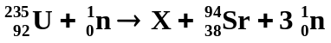

  - Write the nuclide for the missing daughter product labelled X. 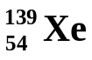 (1 mark)
  - What is the atomic and mass numbers of the daughter product X:
Mass no. ____139________ (1 mark) Atomic no. ____54_________ (1 mark)

- A physics student has three radioactive sources, X, Y and Z. One is a pure α emitter, one is a pure β emitter and one is a pure γ emitter. He uses the following apparatus to decide which is which. The apparatus consists of a holder for the source, a sheet of thin aluminium foil placed in front of the source, a region of magnetic field directed into the page, and three detectors, 1, 2 and 3, arranged as shown below. The student is also told that charged particles will be deflected to the left or to the right when passing through a magnetic field.
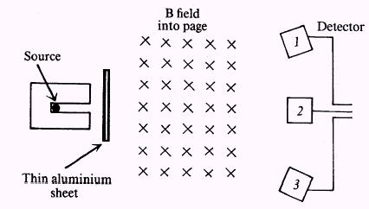
With source X there is no signal from any detector. With source Y there is a signal from detector 3 only. With source Z there is a signal from detector 2 only.

- Which source (X, Y or Z) is the β emitter? (1 mark) Y 1 mark
- Which source (X, Y or Z) is the α emitter? (1 mark) X 1 mark
- Which detector (1, 2 or 3) would most likely detect γ radiation? (1 mark) 2 1 mark
- A student is measuring the decay of a nuclear source. She finds that the source has a count of 8.30 x 10³ decays in a one hour period. Calculate the activity of the source. (2 marks)

A = ΔN = 8.3 x 10³ 1 mark
Δt (60 x 60)
A = 8.3 x 10³
3600
A = 2.31 Bq 1 mark

- The forming of a new element during radioactive decay is called transmutation. Explain why emitting alpha and beta radiation causes a transmutation but emitting gamma radiation does not.
(3 marks)
When alpha radiation leaves the nucleus, the nucleus is reduced by two protons so the atomic number decreases by two and a new element is formed. 1 mark

When beta radiation leaves the nucleus, a neutron is turned into a protons (or a proton to a neutron) and therefore the number of protons changes and so the atomic number changes. 1 mark

With gamma radiation, it is electromagnetic radiation with no mass so the number of protons doesn’t change and neither does the atomic number. 1 mark

4. From the graph, determine the half life of the radioactive isotope. (1 mark)
Show on the graph how you did this. (1 mark
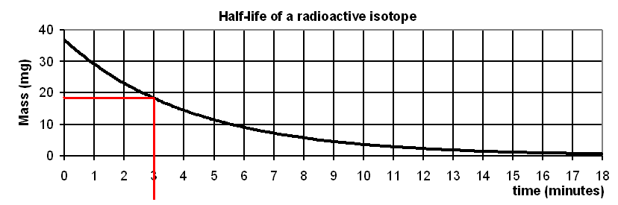
1 mark

Half-life = 3 minutes 1 mark

- In the following reaction 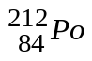 → X + an α particle; the nuclide X is: (1 mark)
A. 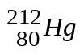 B. 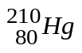 C. 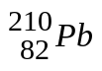 D. 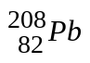 E. 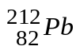
Answer: D 1 mark

- If a radioactive sample has a half-life of 1.50 hours. If the activity of the sample was originally 15.0 kBq, what would the activity be exactly one day later? (2 marks)

Half-life = 1.50 hours A = A₀ (0.5)^{n}
A₀ = 15.0 kBq = 15.0 (0.5)¹⁶
Total time = 24.0 hours = 15 x 1.52588 x 10⁻⁵
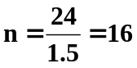 A = 2.29 x 10⁻⁴ kBq (3sf) 1 mark for answer

1 mark for n
Or A = 0.229 Bq (3sf)

- The radio isotope 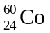has a half-life of approximately 5.00 years. Gamma radiation from a source is used to treat cancer. Hospitals using such sources for therapy usually replace the source when its activity has fallen to 25% of its original value. After how many years must a source be replaced? Show all working. (2 marks)

Half-life = 5.0 years 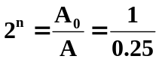
A₀ = 1
A = 0.25 2^{n} = 4
Total time = n x half-life n = 2 1 mark

Total time = n x half-life
= 2 x 5.0
= 10 years

Replace after 10.0 years (3sf) 1 mark

- Household smoke detectors contain a radioactive Americium-241 source. Emitted radiation ionizes air inside a chamber that allows a small current to flow. Smoke particles entering the chamber interrupt the current flow, which sets off the alarm. Americium-241 is an α emitter with a half life of 433 years.

  - Using the information above, briefly discuss why 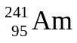 is ideal for use in smoke detectors.
Suggested marking or any suitable answer.

Alpha emits a charged particle with enables the electrical circuit to run.
Alpha is a large, slower moving particle and is stopped by 10 cm of air therefore when smoke (which rises) enters the smoke detector, the alpha particles can’t penetrate the smoke particles and the current flow stops. 1 mark

Beta is small and fast so can penetrate the smoke and the electrical circuit would continue. Gamma being electromagnetic radiation can also penetrate the smoke. 1 mark

  - What would you say to a person who is anxious about having a smoke detector containing a radiation source in their home? (2 marks)

Suggested marking or any suitable answer.

Smoke detectors are on the ceiling and the alpha particles are stopped by about 10 cm of air as well as the plastic casing that mostly encloses the source. 1 mark

On top of this, alpha particles can’t penetrate the skin so unless the alpha emitting source is ingested, the alpha particles can’t cause a problem. 1 mark

